**Project: Banking System**

**Utsav Jitendrabhai Patel: N01516259**

**Pages:**

**index.html**

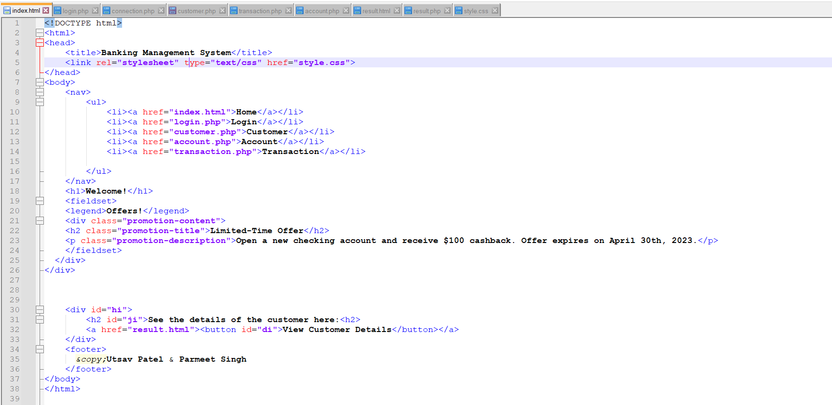

**login.php**

**Connection.php**

**Customer.php**

**Transaction.php**

**Account.php**

**Result.html**

**Result.php**

**Style.css**

**Database:**

**Account Table:**

**Customer Table:**

**Login Table:**

**Transaction Table:**

**Primary keys:**

AccountNumber, CustomerID, Username, TransactionID are primary keys in respective tables.

**Foreign keys:**

* CustomerID in Customer table primary key and in account table foreign key
* AccountNumber in account table primary key and in transaction table foreign key

**Output:**

**Index.html page:**

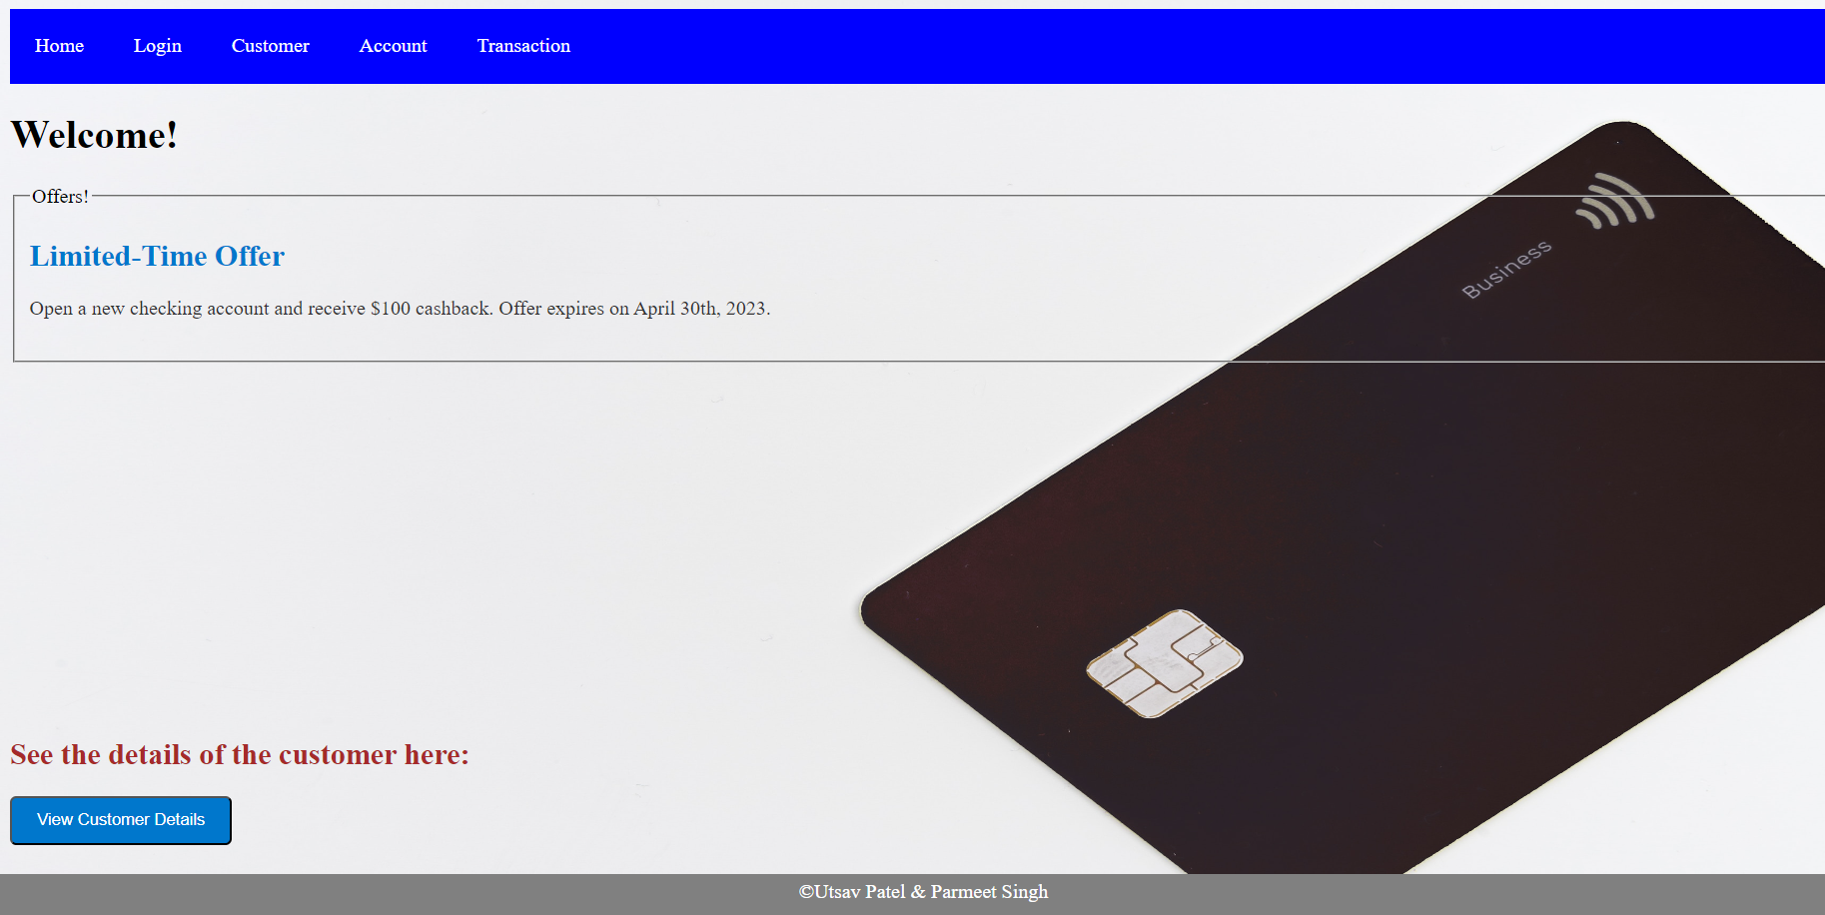

**Login.php page:**

**Validation:**

**Inserting Data:**

**Inserted data in MYSQL tables:**

**Customer.php:**

**Validation:**

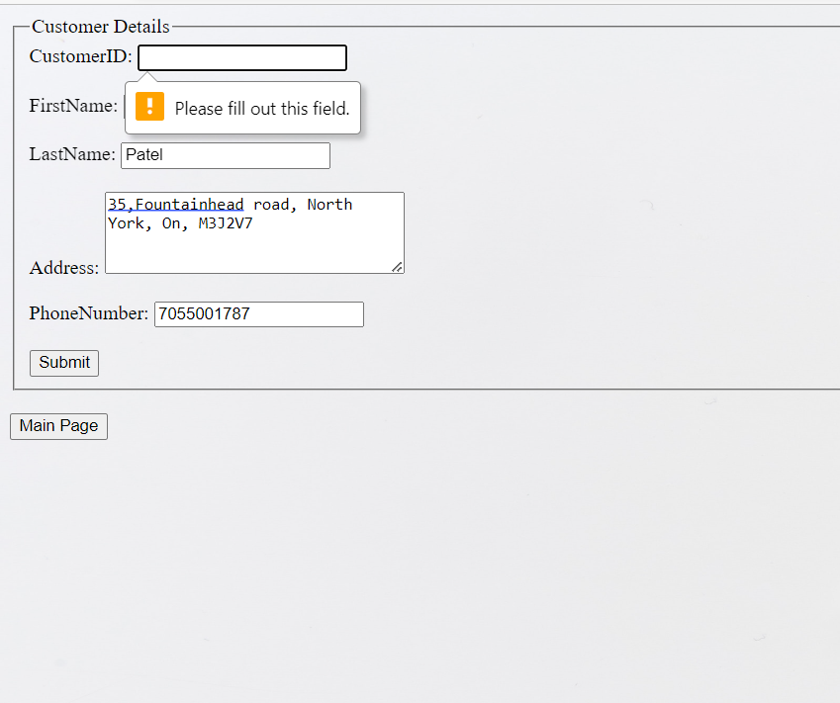

**Inserting Data:**

**Inserted data in MYSQL table:**

**Account.php:**

**Validation:**

**Inserting data:**

**Inserted data in MYSQL table:**

**Transaction.php**

**Validation:**

**Inserting data:**

**Inserted data in MYSQL Table:**

**View Customer Details that we are inserted:**

**Result.html**

**Inserted CustomerID:**

**Detail of CustomerID that we inserted in the UserInput in result.php page:**

